Driving Directions to North Cobb High School,
3400 Hwy 293 North, Kennesaw, GA 30144
See the next page for the second map for parking.
North Cobb is the size of a community college so please park where directed to save a VERY long walk around the entire building. Everything is locked except the areas we are using.

For food – If you go North on Cobb Parkway, there are many choices.

Driving Map – follow the pink, do NOT go through downtown Kennesaw – Festival Event will cause delays
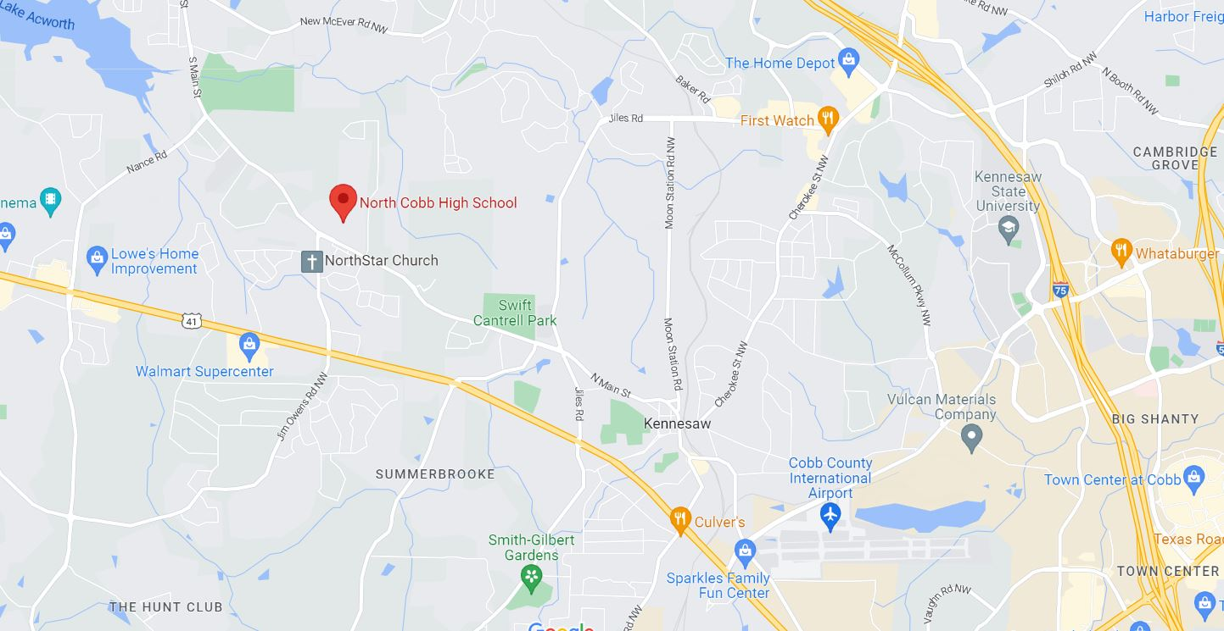

From I-75, take exit 271 for Kennesaw State University and go west on Chastain Road.
Go west on Chastain Rd until you reach Hwy 41 / Cobb Parkway North
Go north on Hwy 41 / Cobb Parkway North until you reach Blue Springs Rd
(just past Tractor Supply and before the Aldis)
When Blue Springs dead ends, go right onto Old Hwy 41-- DO NOT GO STRAIGHT -This is the gym parking lot.

Parking Directions at North Cobb High School – follow the pink
When Blue Springs dead ends, go right onto old Hwy 41 (DO NOT GO STRAIGHT -This is the gym parking lot.
From Old Hwy 41, take a left at the first light onto Nowlin Rd
Once on Nowlin Rd, proceed to the 2nd entrance on the left to enter NCHS – follow the yard signs for project set up
Drive up and you can drop off your project and then park in the lot.

Parking Map - follow the pink
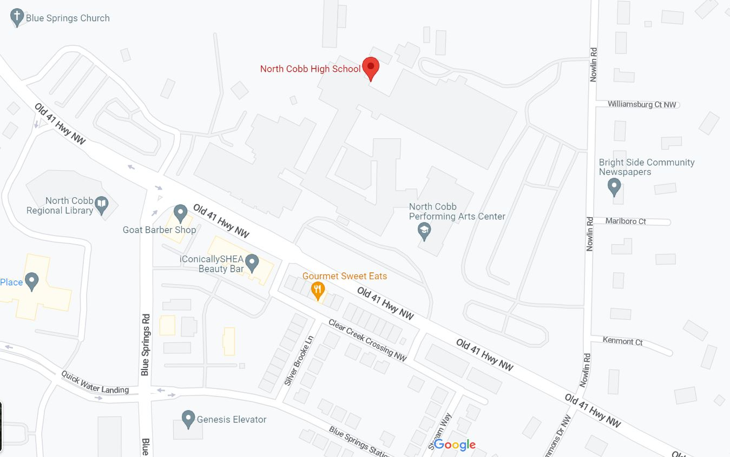
Parking
Judges Parking
Judges Entrance
Parking 2
Project Drop Off

Judges Parking Directions at North Cobb High School
When Blue Springs dead ends, go right onto old Hwy 41 (DO NOT GO STRAIGHT -This is the gym parking lot.
From Old Hwy 41, take a left and enter at the front of the school – blue line on the map.
Enter at the awning and sign in at the table please.

